”Feel in the blanks” by 山地
1.2021 - 5.2021

In 2021, I put 2019 in the bracket as it’s too overwhelming.

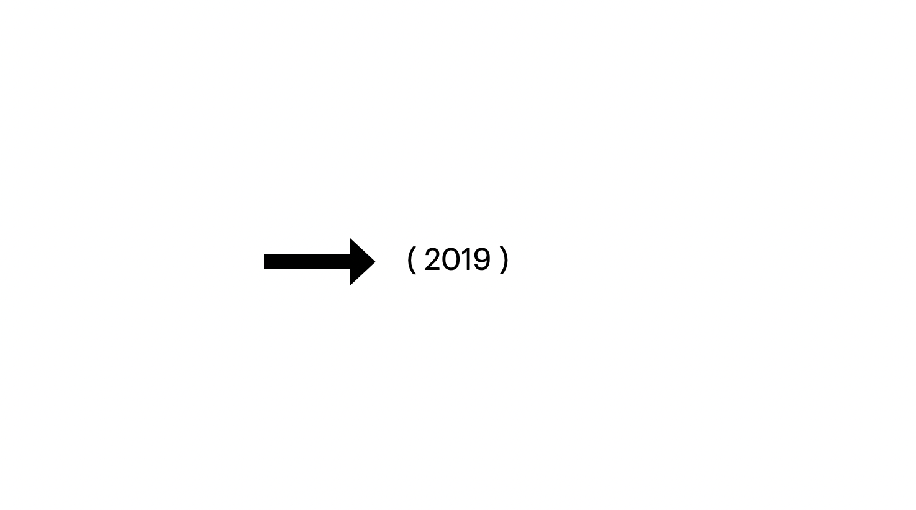

Like a blank in my timeline,
The past has paused and the future stops going on.
Business cannot be usual.
What worked no longer works and the new way is not yet unfolding.

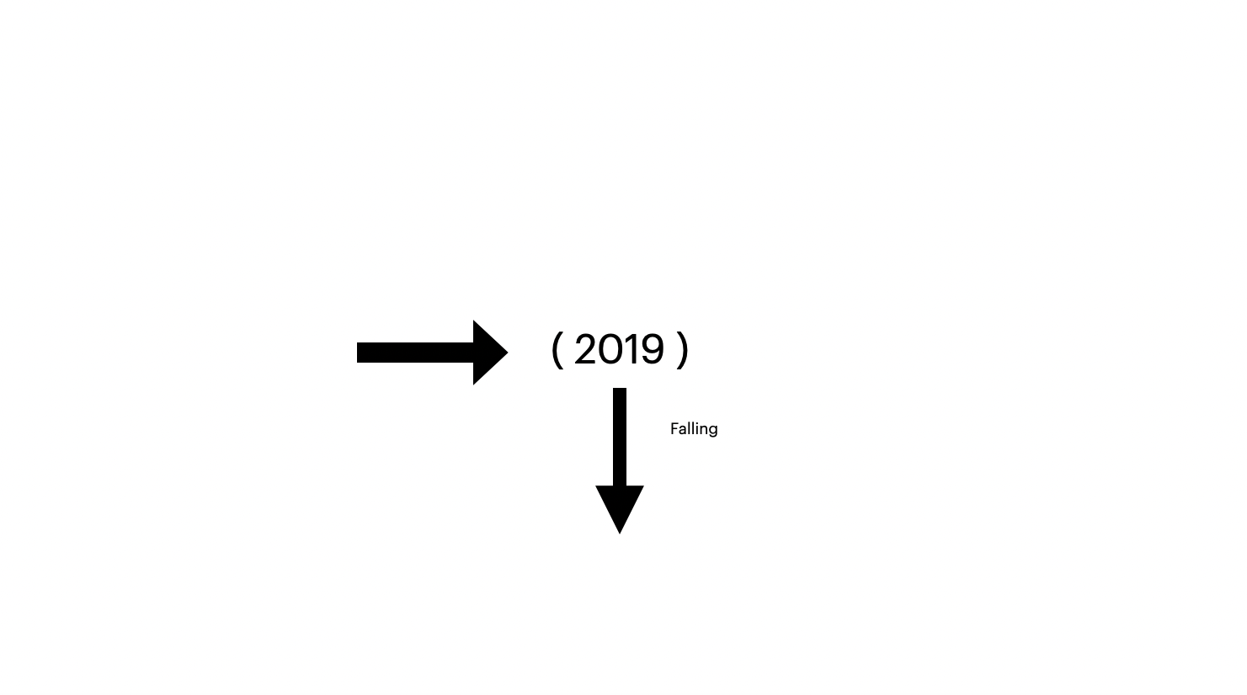

Right before me, my beloved Hong Kong collapsed.
My heart cracked open and so was my body.
I can hear a loud but soundless scream from deep deep inside.
I find myself falling in a dark and damp liminal space,
like a black hole without time and space.

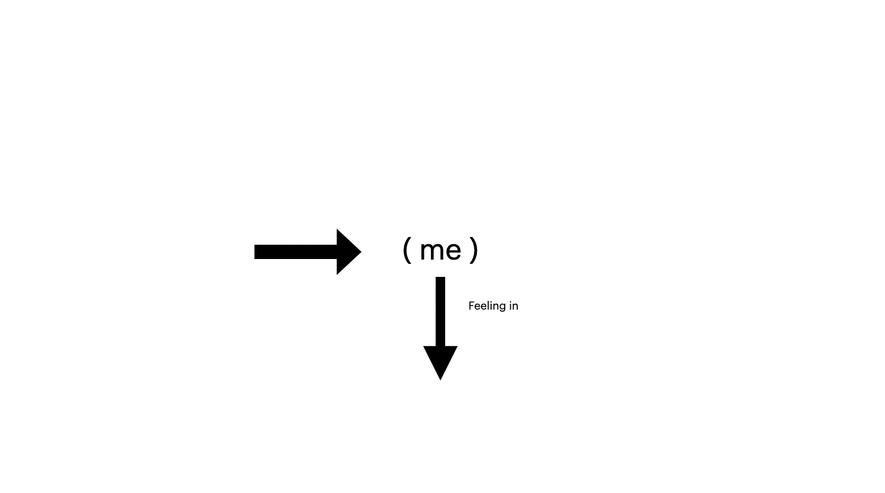

I have been struggling and trying hard to find my way out.
Hope for transformation but in vain.
I stopped filling in the void but “feeling” in the blanks.
Putting all things between parentheses including myself.
suspending (me ) [ you ] 「 we 」“ hong kong” ﹝future〕【2019】
That’s how my “feel in the blank” unfolds.

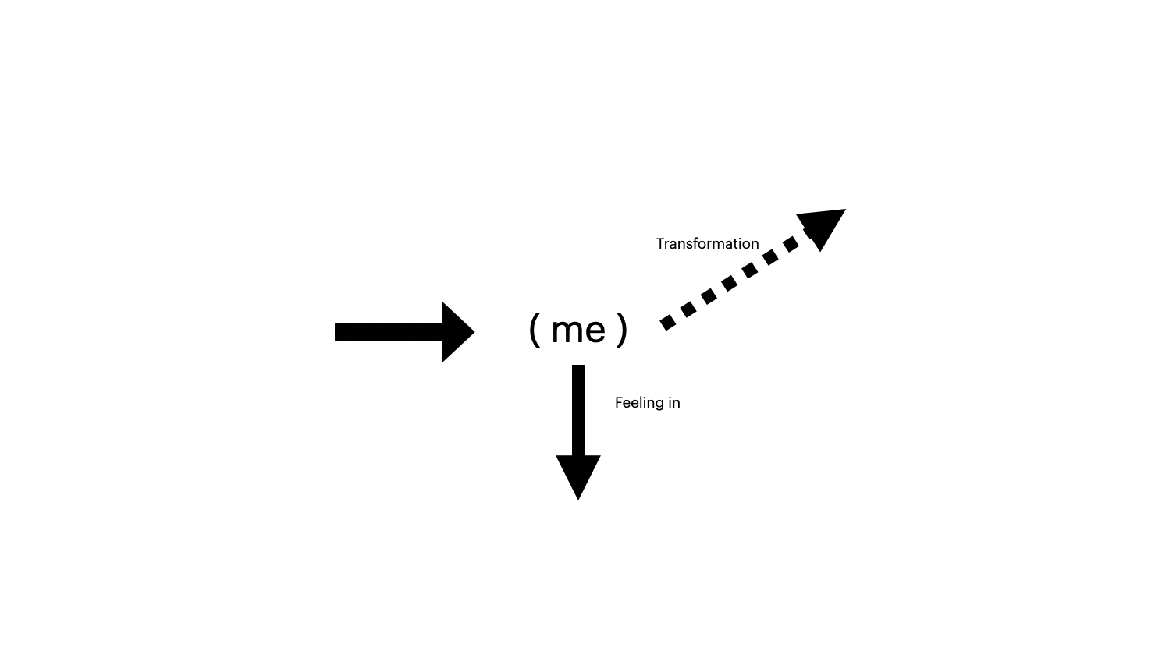

Drawing without planning, let my hands guide my thoughts.
Moving from within, let my legs lead the way.
Writing as breathing, let the words fill the line.
Seeing from new eyes, let the non-human beings witness.
Response without judging, let curiosity take the lead.
The world is changing but my world is becoming that I am still pondering.

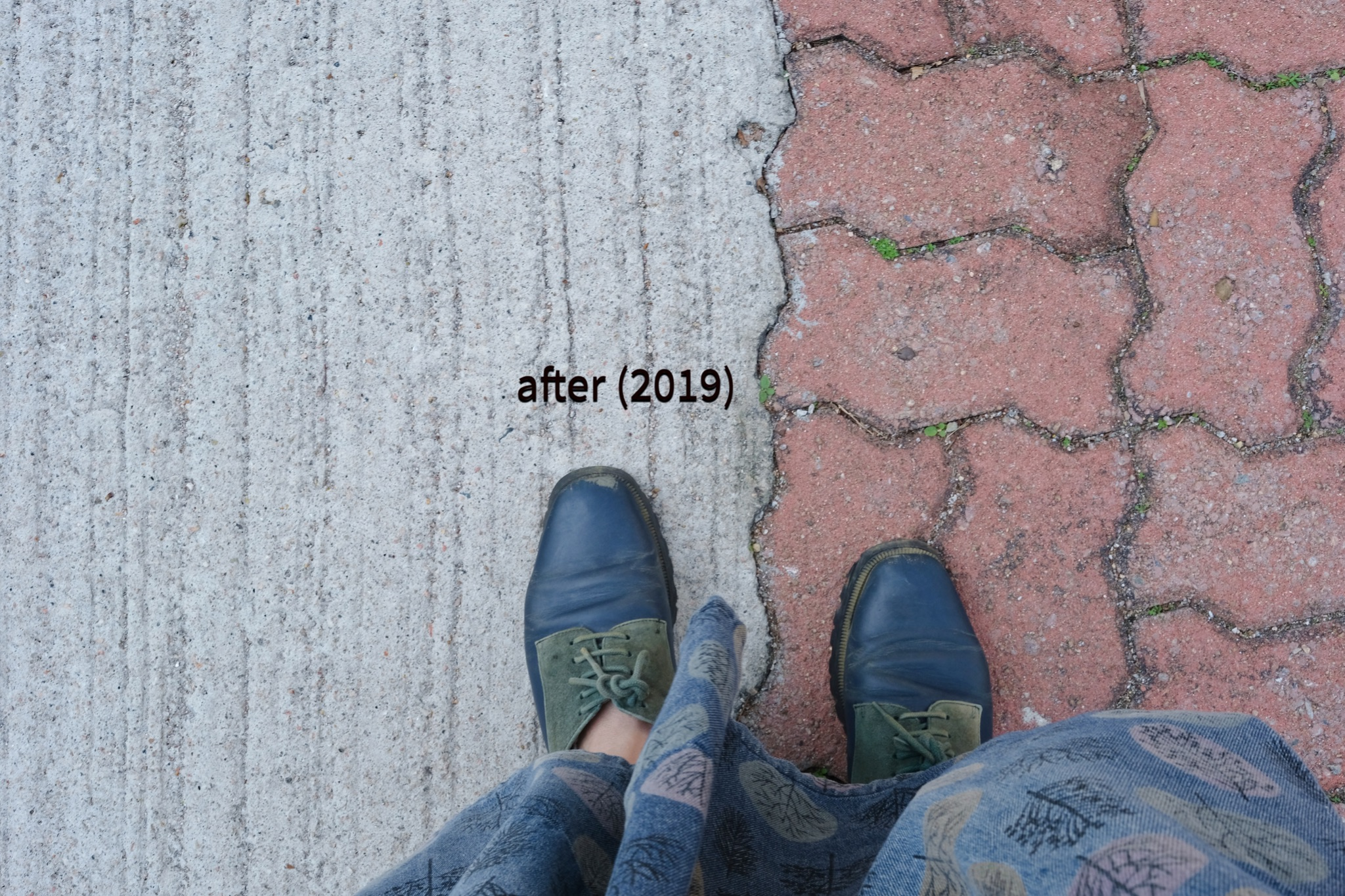Bricks on the road have been the weapons of the activists on the street.
After (2019), cement has been filled in all the blanks left by the bricks.
I was sad until someone told me, “there are little plants growing from the cracks”.

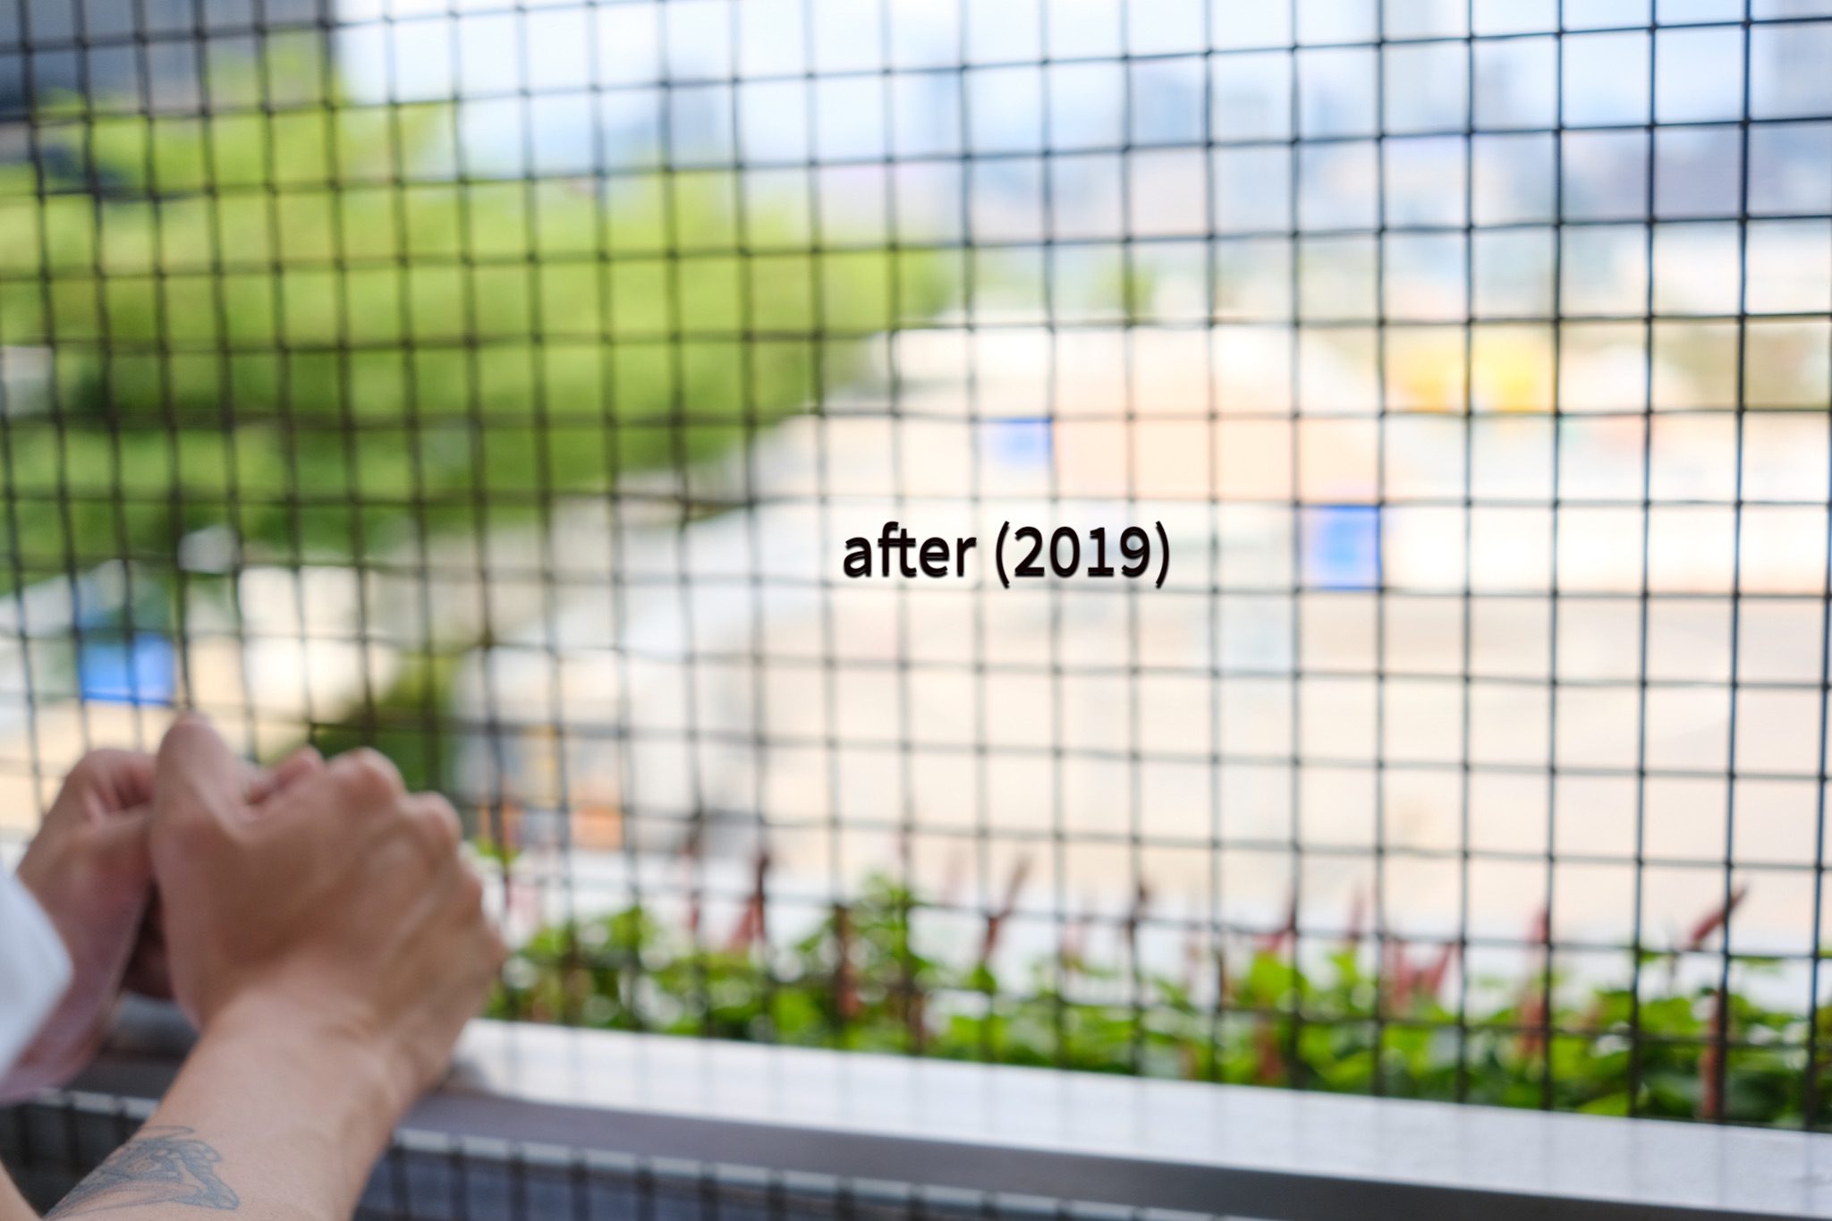
There were places where people have gathered,
After (2019), all these places are fenced with wire.
I was anguished until someone told me, “I saw these little plants and they are still there.”

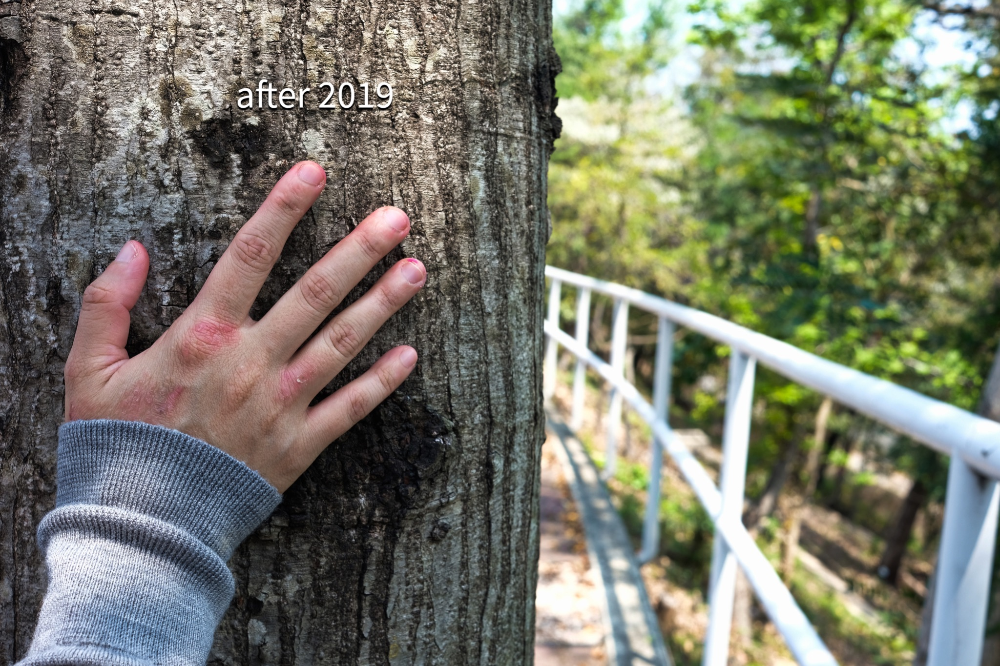
The roads has been crowded with people around,
After (2019), people are forbidden to gather.
I was so lonely until someone told me, “The trees are still there and they have witnessed.”

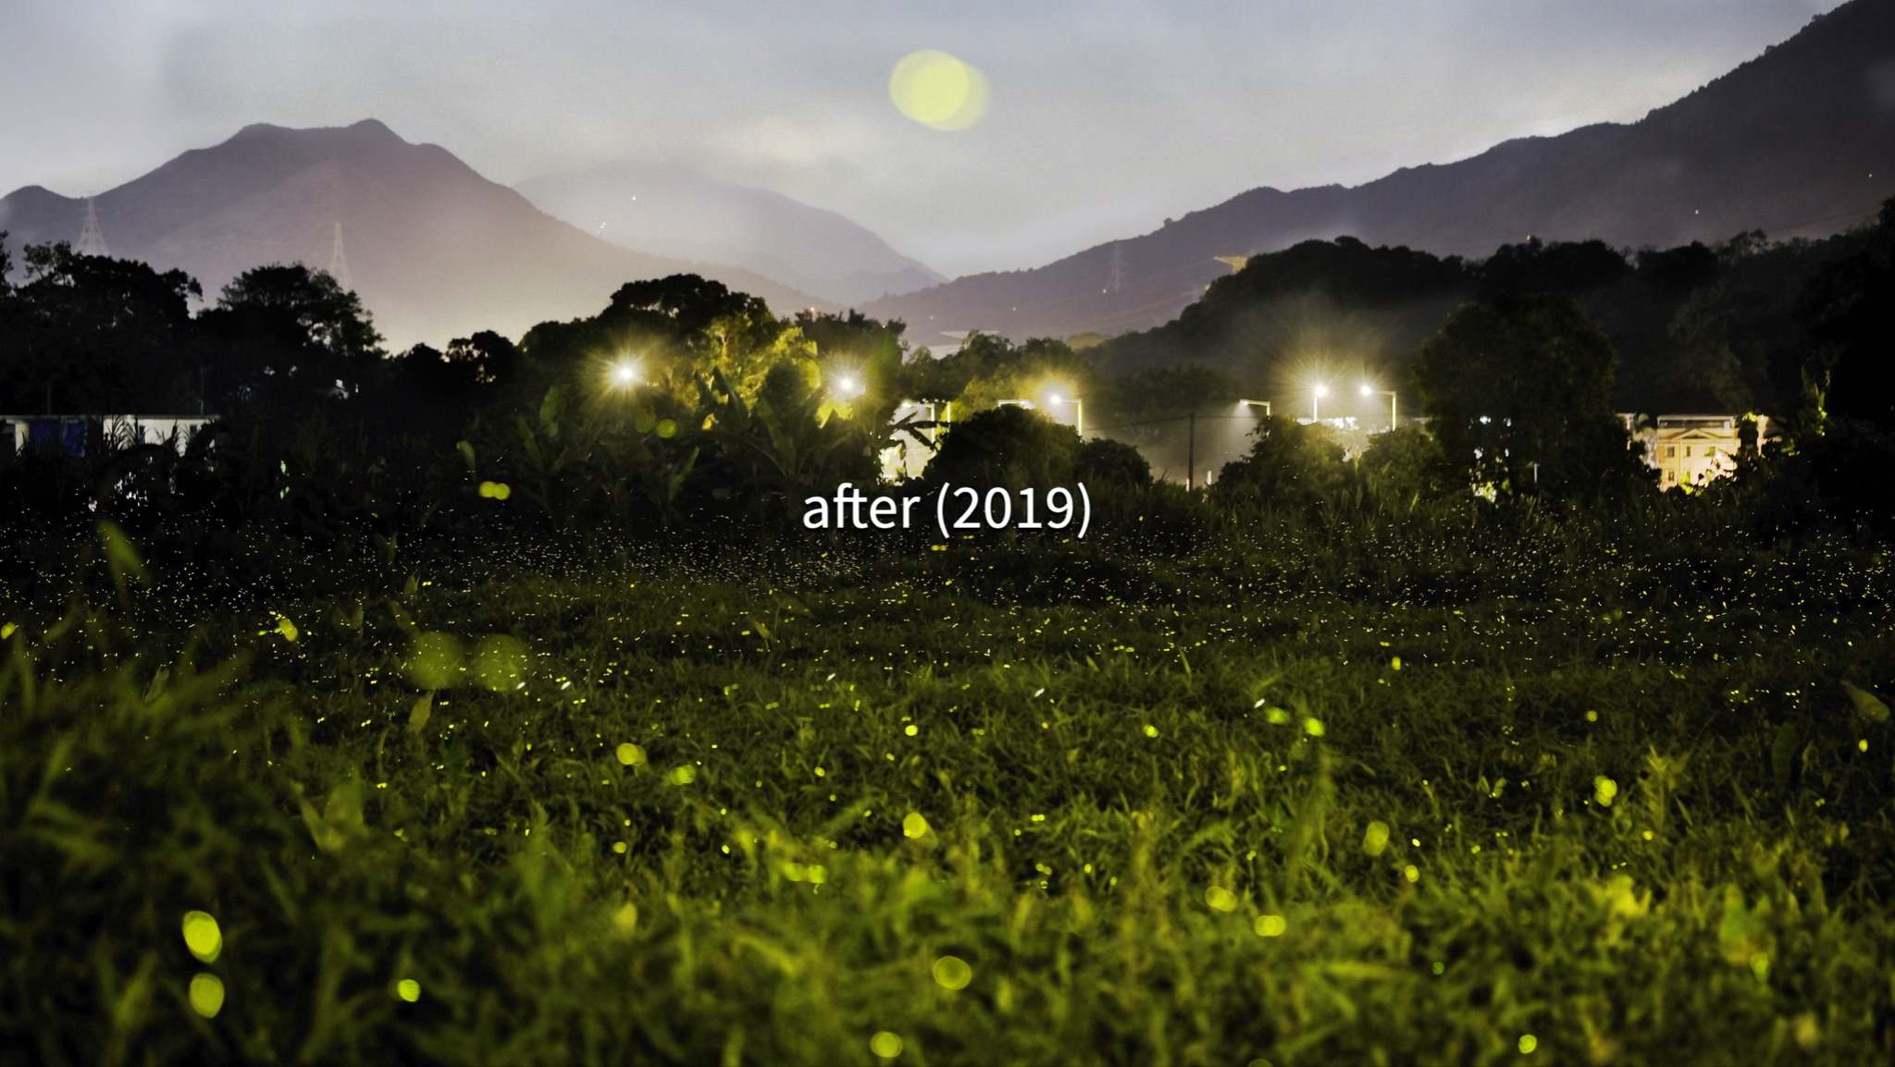
The darkness have been illuminated by the willpower of people,
After (2019), it becomes darker and darker every night.
I was so desperate until someone told me, “The fireflies are bursting, following the rhythm of nature.”

I also dig deep into my love of Hong Kong. Literally I dig deep into the soil of Hong Kong, searching for the root of our stories. I seized the clay out and moulded it into the human being who lives on the soil. During this process, I listened to his/her story. While moulding, I let my feelings out. The clay does speak. Taking time and undergoing strong fires, I contemplate how our lives are moulded.

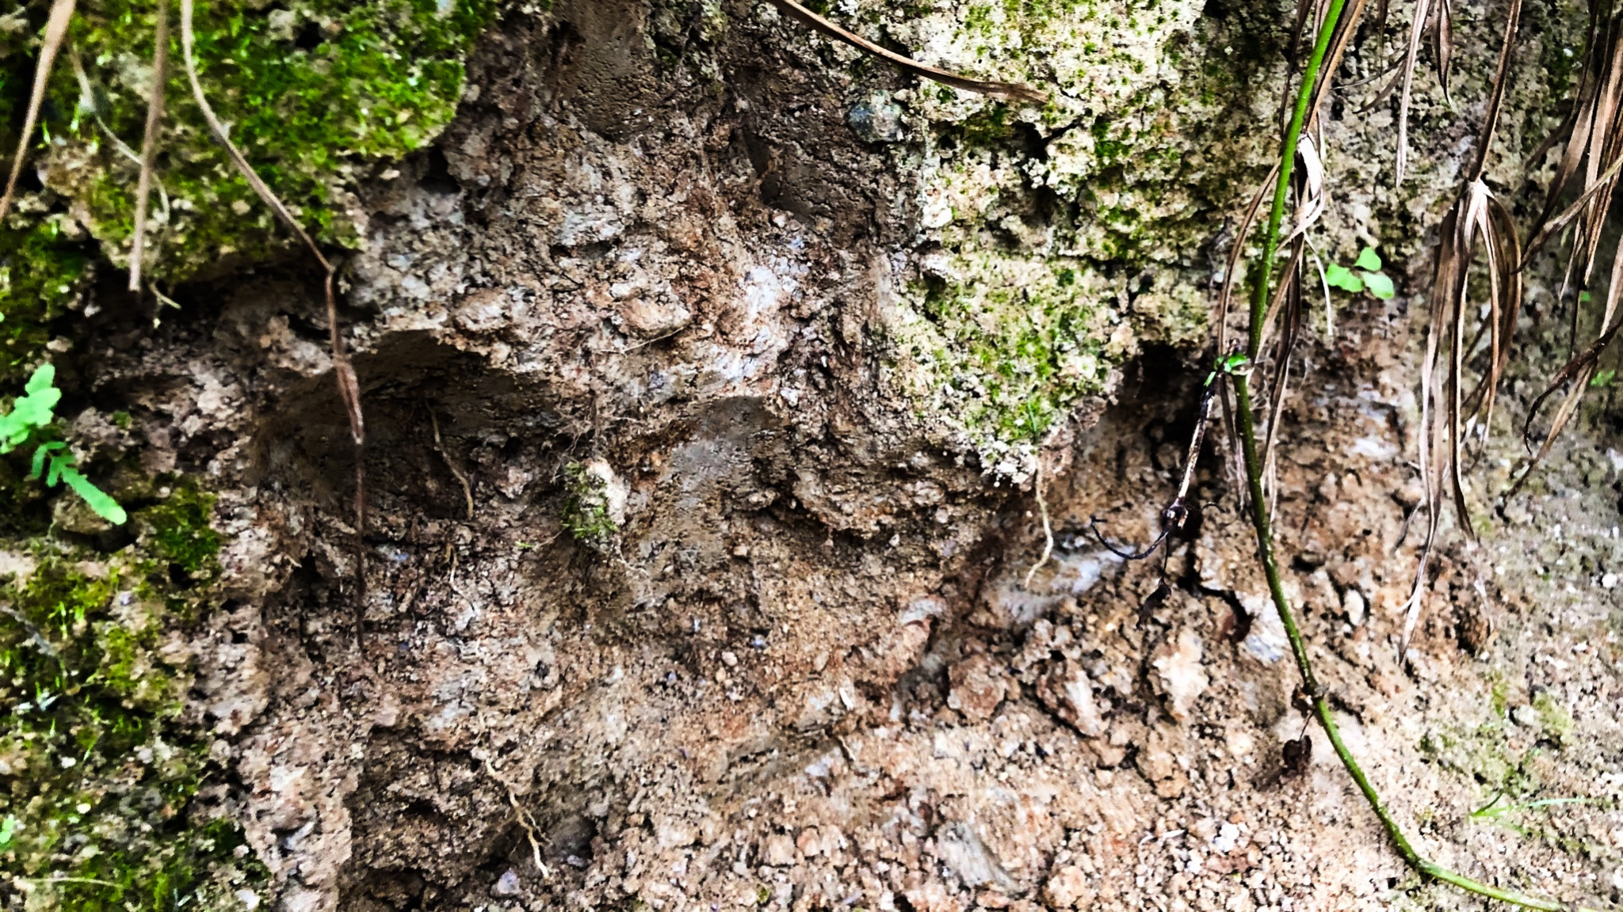
The wild soil in Nam Chung.
2/2021
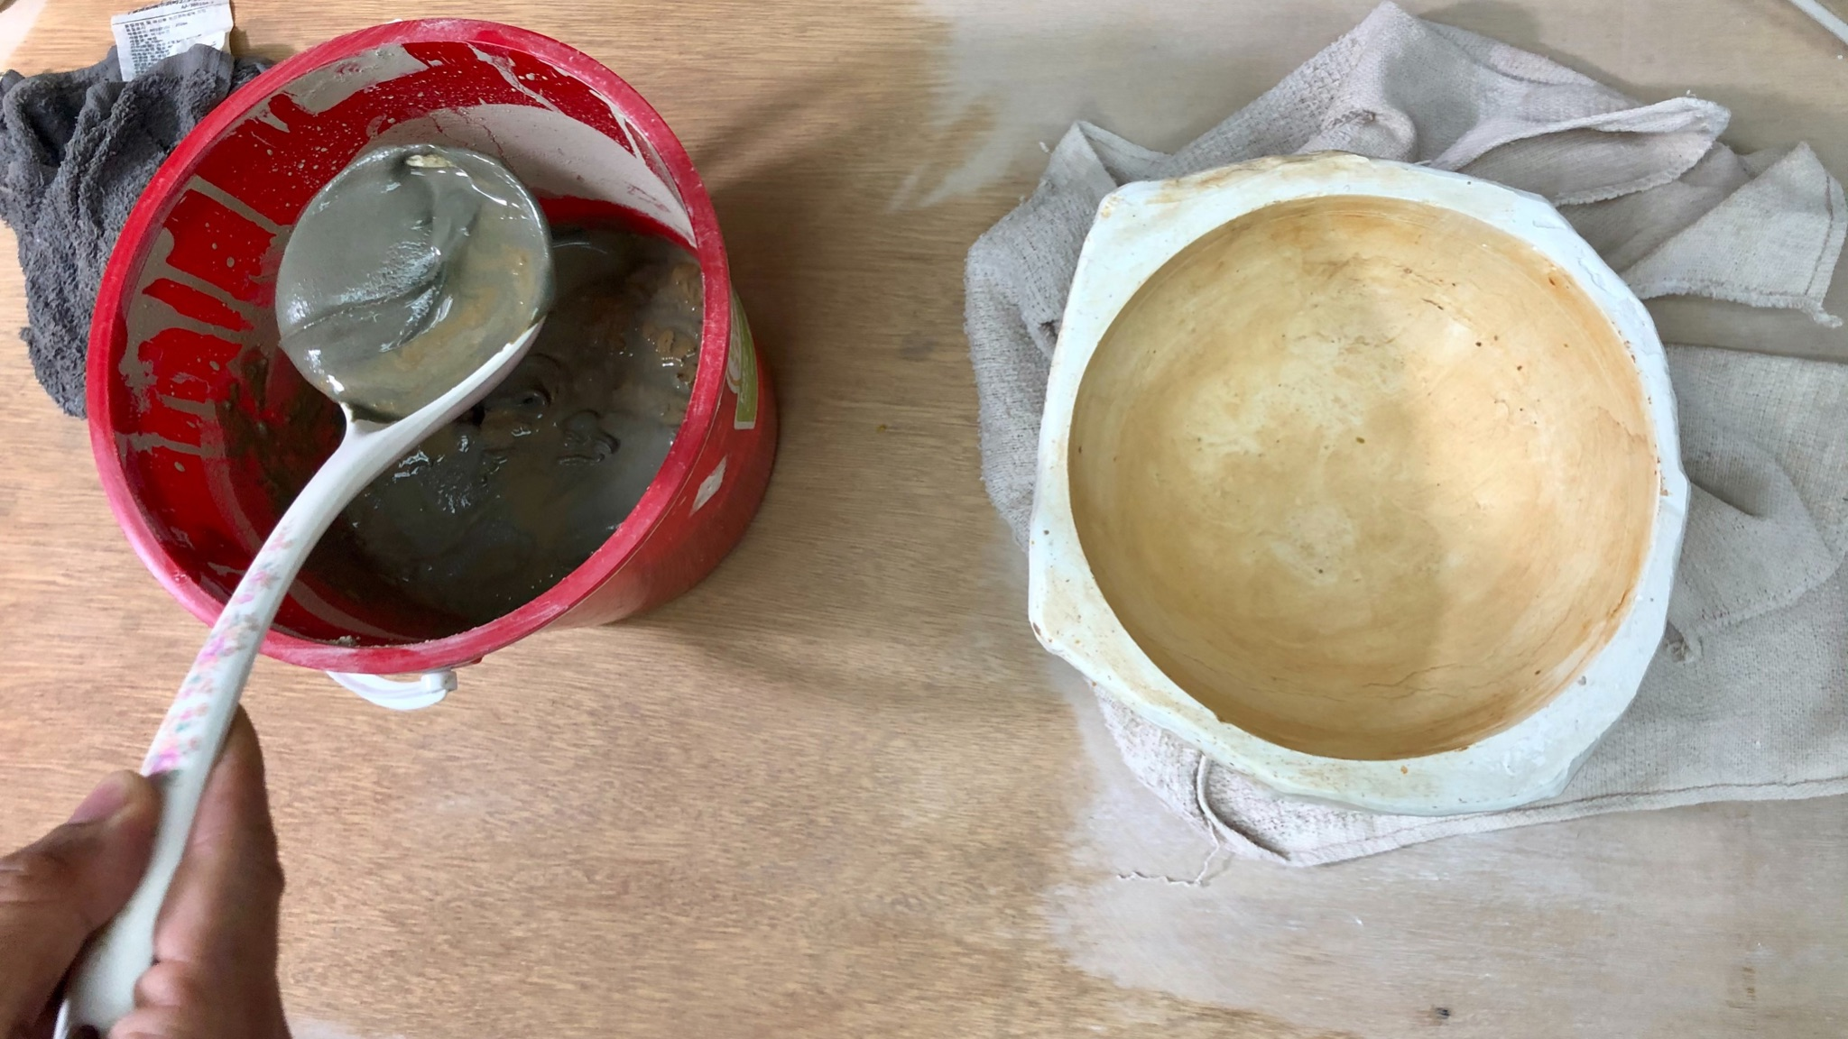
Sieve he clay out the soil
2/2021

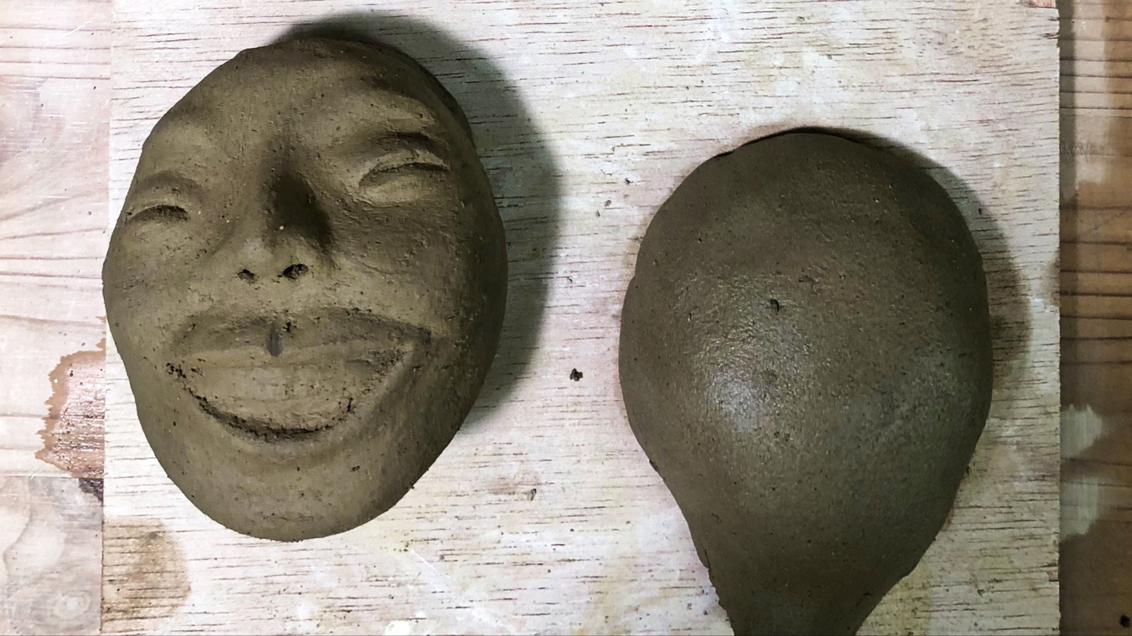
Moulding the figure out
3/2021

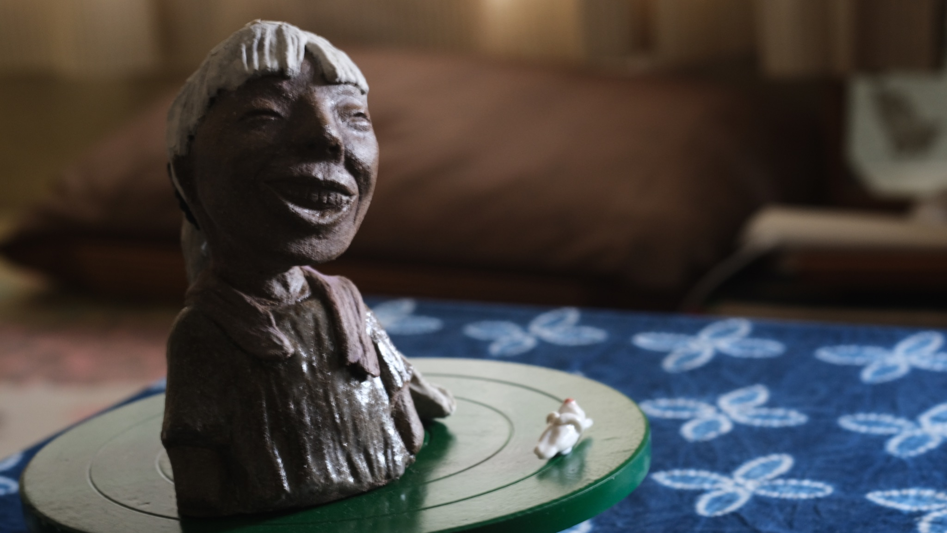
after glaze firing
5/2021

